**-GROUP 7**

-Group Members :

1.Tatiana Tan

2.Arun Sharma

-Date: 07/16/2024

-Assignment: Module – 10 Milestone #2

-GitHub link: <https://github.com/SharmaArun017/CSD310.git>

= Arun Sharma

-GitHub link: <https://github.com/pocacuntas/csd-310>

= Tatiana Tan

Here is the revised ERD with additional attributes and ensured 3NF:

**Entities and Attributes:**

1. **Wine**
   * WineID (PK)
   * WineName
   * Type
   * Price
2. **Supplier**
   * SupplierID (PK)
   * SupplierName
   * ContactInfo
3. **Supply**
   * SupplyID (PK)
   * SupplyType
   * Quantity
   * SupplierID (FK)
4. **Distributor**
   * DistributorID (PK)
   * DistributorName
   * ContactInfo
5. **Order**
   * OrderID (PK)
   * OrderDate
   * DistributorID (FK)
6. **OrderDetails**
   * OrderDetailsID (PK)
   * OrderID (FK)
   * WineID (FK)
   * Quantity
7. **Employee**
   * EmployeeID (PK)
   * EmployeeName
   * Department
   * HoursWorked

### **Relationships:**

* One supplier can provide many supplies (Supplier to Supply - One-to-Many).
* One distributor can place many orders (Distributor to Order - One-to-Many).
* One order can have many order details (Order to OrderDetails - One-to-Many).
* One wine can appear in many order details (Wine to OrderDetails - One-to-Many).
* Employees have their working hours tracked (Employee - One-to-One for simplicity).

**Sql Code:**

CREATE DATABASE BacchusWinery;

USE BacchusWinery;

-- Create tables

CREATE TABLE Wine (

WineID INT PRIMARY KEY AUTO_INCREMENT,

WineName VARCHAR(50),

Type VARCHAR(50),

Price DECIMAL(10, 2)

);

CREATE TABLE Supplier (

SupplierID INT PRIMARY KEY AUTO_INCREMENT,

SupplierName VARCHAR(100),

ContactInfo VARCHAR(100)

);

CREATE TABLE Supply (

SupplyID INT PRIMARY KEY AUTO_INCREMENT,

SupplyType VARCHAR(50),

Quantity INT,

SupplierID INT,

FOREIGN KEY (SupplierID) REFERENCES Supplier(SupplierID)

);

CREATE TABLE Distributor (

DistributorID INT PRIMARY KEY AUTO_INCREMENT,

DistributorName VARCHAR(100),

ContactInfo VARCHAR(100)

);

CREATE TABLE Orders (

OrderID INT PRIMARY KEY AUTO_INCREMENT,

OrderDate DATE,

DistributorID INT,

FOREIGN KEY (DistributorID) REFERENCES Distributor(DistributorID)

);

CREATE TABLE OrderDetails (

OrderDetailsID INT PRIMARY KEY AUTO_INCREMENT,

OrderID INT,

WineID INT,

Quantity INT,

FOREIGN KEY (OrderID) REFERENCES Orders(OrderID),

FOREIGN KEY (WineID) REFERENCES Wine(WineID)

);

CREATE TABLE Employee (

EmployeeID INT PRIMARY KEY AUTO_INCREMENT,

EmployeeName VARCHAR(100),

Department VARCHAR(50),

HoursWorked INT

);

-- Insert sample data

INSERT INTO Wine (WineName, Type, Price) VALUES

('Merlot', 'Red', 15.50),

('Cabernet', 'Red', 20.00),

('Chablis', 'White', 12.75),

('Chardonnay', 'White', 18.25);

INSERT INTO Supplier (SupplierName, ContactInfo) VALUES

('Bottle Supplier', '123-456-7890'),

('Label Supplier', '234-567-8901'),

('Vats Supplier', '345-678-9012');

INSERT INTO Supply (SupplyType, Quantity, SupplierID) VALUES

('Bottles', 1000, 1),

('Corks', 2000, 1),

('Labels', 1500, 2),

('Boxes', 500, 2),

('Vats', 10, 3),

('Tubing', 100, 3);

INSERT INTO Distributor (DistributorName, ContactInfo) VALUES

('Wine Distributors Inc.', '456-789-0123'),

('Global Wines', '567-890-1234'),

('Local Wine Shop', '678-901-2345');

INSERT INTO Orders (OrderDate, DistributorID) VALUES

('2024-07-01', 1),

('2024-07-02', 2),

('2024-07-03', 3);

INSERT INTO OrderDetails (OrderID, WineID, Quantity) VALUES

(1, 1, 50),

(1, 2, 30),

(2, 3, 20),

(2, 4, 25),

(3, 1, 15),

(3, 3, 10);

INSERT INTO Employee (EmployeeName, Department, HoursWorked) VALUES

('Janet Collins', 'Finance', 160),

('Roz Murphy', 'Marketing', 150),

('Bob Ulrich', 'Marketing', 140),

('Henry Doyle', 'Production', 170),

('Maria Costanza', 'Distribution', 155),

('Stan Bacchus', 'Management', 180);

Python Script:

import mysql.connector # Import the mysql.connector module to connect to the MySQL database

# Connect to the MySQL database

connection = mysql.connector.connect(

host='localhost', # Database host

user='root', # Database username

password='######', # Database password

database='BacchusWinery' # Database name

)

cursor = connection.cursor() # Create a cursor object to interact with the database

# Function to display table data

def display_table(table_name):

cursor.execute(f"SELECT * FROM {table_name}") # Execute SQL query to select all data from the table

rows = cursor.fetchall() # Fetch all the rows from the executed query

headers = [i[0] for i in cursor.description] # Get the column headers from the cursor description

# Print table name

print(f"\n{table_name} Table")

# Print headers

print(" | ".join(headers))

# Print separator line

print("-" * (len(" | ".join(headers))))

# Print rows

for row in rows:

print(" | ".join(str(col) for col in row))

# List of tables to display

tables = ['Wine', 'Supplier', 'Supply', 'Distributor', 'Orders', 'OrderDetails', 'Employee']

# Loop through each table and display its data

for table in tables:

display_table(table)

# Close the cursor and the connection to the database

cursor.close() # Close the cursor

connection.close() # Close the connection

OUTPUT SCREENSHOT:

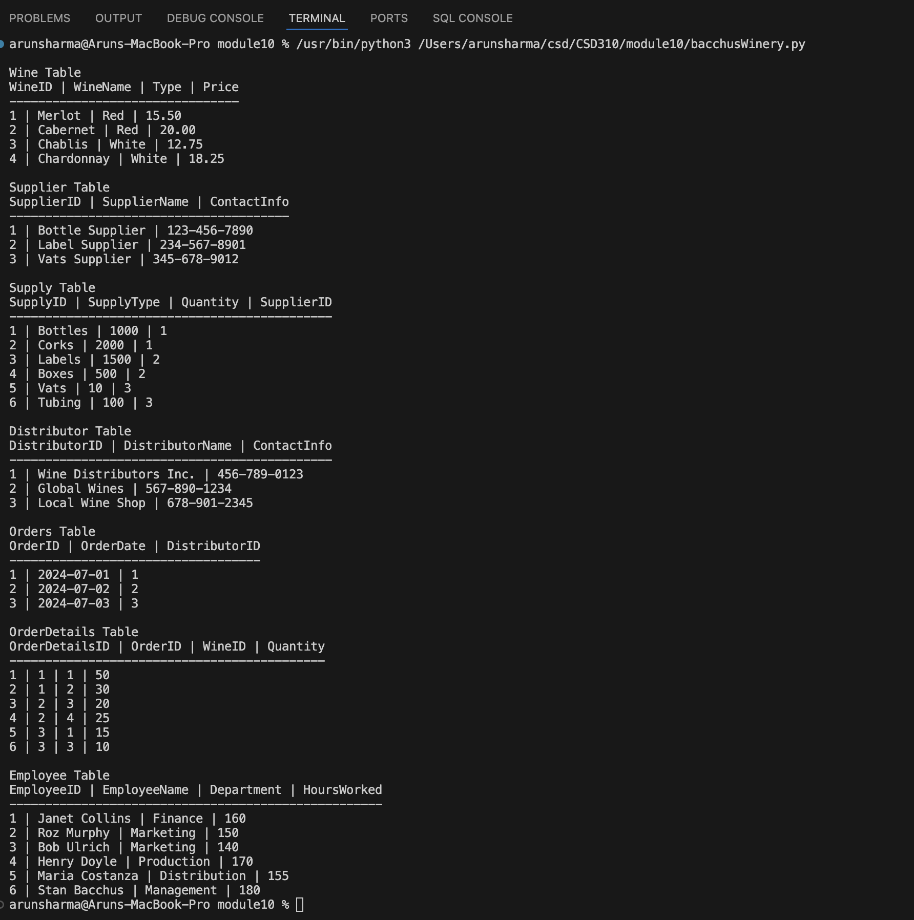

= Tatiana tan

SQL CODE:

CREATE DATABASE BacchusWinery;

USE BacchusWinery;

-- Create tables

CREATE TABLE Wine (

WineID INT PRIMARY KEY AUTO_INCREMENT,

WineName VARCHAR(50),

Type VARCHAR(50),

Price DECIMAL(10, 2)

);

CREATE TABLE Supplier (

SupplierID INT PRIMARY KEY AUTO_INCREMENT,

SupplierName VARCHAR(100),

ContactInfo VARCHAR(100)

); CREATE TABLE Supply (

SupplyID INT PRIMARY KEY AUTO_INCREMENT,

SupplyType VARCHAR(50),

Quantity INT,

SupplierID INT,

FOREIGN KEY (SupplierID) REFERENCES Supplier(SupplierID)

);

CREATE TABLE Distributor (

DistributorID INT PRIMARY KEY AUTO_INCREMENT,

DistributorName VARCHAR(100),

ContactInfo VARCHAR(100)

); CREATE TABLE Orders (

OrderID INT PRIMARY KEY AUTO_INCREMENT,

OrderDate DATE,

DistributorID INT,

FOREIGN KEY (DistributorID) REFERENCES Distributor(DistributorID)

);

CREATE TABLE OrderDetails (

OrderDetailsID INT PRIMARY KEY AUTO_INCREMENT,

OrderID INT,

WineID INT,

Quantity INT,

FOREIGN KEY (OrderID) REFERENCES Orders(OrderID),

FOREIGN KEY (WineID) REFERENCES Wine(WineID)

);

CREATE TABLE Employee (

EmployeeID INT PRIMARY KEY AUTO_INCREMENT,

EmployeeName VARCHAR(100),

Department VARCHAR(50),

HoursWorked INT

);

-- Insert sample data

INSERT INTO Wine (WineName, Type, Price) VALUES

('Merlot', 'Red', 15.50),

('Cabernet', 'Red', 20.00),

('Chablis', 'White', 12.75),

('Chardonnay', 'White', 18.25);

INSERT INTO Supplier (SupplierName, ContactInfo) VALUES

('Bottle Supplier', '123-456-7890'),

('Label Supplier', '234-567-8901'),

('Vats Supplier', '345-678-9012');

INSERT INTO Supply (SupplyType, Quantity, SupplierID) VALUES

('Bottles', 1000, 1),

('Corks', 2000, 1),

('Labels', 1500, 2),

('Boxes', 500, 2),

('Vats', 10, 3),

('Tubing', 100, 3);

INSERT INTO Distributor (DistributorName, ContactInfo) VALUES

('Wine Distributors Inc.', '456-789-0123'),

('Global Wines', '567-890-1234'),

('Local Wine Shop', '678-901-2345');

INSERT INTO Orders (OrderDate, DistributorID) VALUES

('2024-07-01', 1),

('2024-07-02', 2),

('2024-07-03', 3);

INSERT INTO OrderDetails (OrderID, WineID, Quantity) VALUES

(1, 1, 50),

(1, 2, 30),

(2, 3, 20),

(2, 4, 25),

(3, 1, 15),

(3, 3, 10);

INSERT INTO Employee (EmployeeName, Department, HoursWorked) VALUES

('Janet Collins', 'Finance', 160),

('Roz Murphy', 'Marketing', 150),

('Bob Ulrich', 'Marketing', 140),

('Henry Doyle', 'Production', 170),

('Maria Costanza', 'Distribution', 155),

('Stan Bacchus', 'Management', 180);

PYTHON CODE:

import mysql.connector # Import the mysql.connector module to connect to the MySQL database

# Connect to the MySQL database

connection = mysql.connector.connect(

host='localhost', # Database host

user='root', # Database username

password='Peppabeppa12.', # Database password

database='BacchusWinery' # Database name

)

cursor = connection.cursor() # Create a cursor object to interact with the database

# Function to display table data

def display_table(table_name):

cursor.execute(f"SELECT * FROM {table_name}") # Execute SQL query to select all data from the table

rows = cursor.fetchall() # Fetch all the rows from the executed query

headers = [i[0] for i in cursor.description] # Get the column headers from the cursor description

# Print table name

print(f"\n{table_name} Table")

# Print headers

print(" | ".join(headers))

# Print separator line

print("-" * (len(" | ".join(headers)) + 3 * (len(headers) - 1)))

# Print rows

for row in rows:

print(" | ".join(str(col) for col in row))

# List of tables to display

tables = ['Wine', 'Supplier', 'Supply', 'Distributor', 'Orders', 'OrderDetails', 'Employee']

# Loop through each table and display its data

for table in tables:

display_table(table)

# Close the cursor and the connection to the database

cursor.close() # Close the cursor

connection.close() # Close the connection

SCREENSHOT OF OUTPUT:

